

Business Template

Jackpot Insights


Contents

1 Business Description 3
1.1 Business background 3
1.2 Problems because of poor data management 3
1.3 Benefits from implementing a Data Warehouse 3
1.4 DATASETS DESCRIPTION 4
1.5 GRAIN / DIM / FACT 7
1. Selecting the Business Process 7
2. Declaring the Grain 7
3. Identifying the Dimensions 8
4. Identifying the Facts 9
2 Business Layer 3NF 17
3 Business Layer Dimensional Model 19
4 Logical Scheme 19
5 Data Flow 19
6 Fact Table Partitioning Strategy 19

Business Description

Business background
Lottery games, or luck-based games as we might call them, are part of a large and profitable
industry around the world. People keep playing because of the strong desire to win
big—sometimes just by scratching a ticket or picking a few lucky numbers. These games
continue to be popular in many places.
In the United States, the lottery market is very large, and Texas stands out as one of the
top states in terms of ticket sales. That’s why this project focuses specifically on the Texas
lottery. There are still many important questions to explore: Which games are the most or
least profitable? What types of games do people in Texas prefer? Are instant-win scratch
games more popular, or do players prefer waiting for draw results?
To find answers, it is important to understand how consumers behave, how well different
games perform, and how retailers contribute to sales. This can be done by collecting and
analyzing structured sales data from across Texas, which will help reveal useful insights and
support better business decisions in this growing industry.

Problems because of poor data management
Poor data management can significantly hinder success in the lottery business. Without
proper data, it’s difficult to know which games are doing well and which ones are not. If
you don’t use tools that help you collect and analyze sales information, you won’t be able
to understand what players want or how retailers are performing.
In a competitive market like the Texas lottery, not having the right data can lead to
missed opportunities, poor planning, and less profit. To stay competitive and make smart
decisions, it’s important to manage data properly and use it to create effective strategies.

Benefits from implementing a Data Warehouse
Using a data warehouse can help solve the problems mentioned above. Implementing a data
warehouse can answer important questions like:
• Which lottery games generate the most revenue?
• Which games have the widest range of sales across different retailers?
• Are there clear patterns in player preferences for instant-win versus draw-based games?
Further analysis of the data can also help to:
• Understand how sales vary by region or retailer type.
• Identify trends in customer behavior over time.
• Improve marketing strategies by targeting popular games.
• And many other useful insights.
By collecting and organizing data in one place, a data warehouse makes it easier to
analyze sales, support better decision-making, and improve overall business performance.

DATASETS DESCRIPTION
In our project, we examine the performance of lottery games across different regions of the state of Texas, focusing on two distinct source systems and two key years: 2021 and 2022. These years are particularly significant as 2021 marked the early post-COVID period, still affected by restrictions and shifts in consumer behavior.
We have designed two separate source datasets:
- SRC_LOTTERY_SCRATCH_OFF: Contains all sales transactions related to scratch-off lottery tickets.
- SRC_LOTTERY_DRAW: Contains all sales transactions related to draw-based lottery games.
This division reflects two fundamentally different player mindsets. Scratch-off games provide instant win opportunities, feature variable pricing across retailers, and generally offer better odds. In contrast, draw-based games have fixed prices, are standardized across vendors, and typically offer much lower odds of winning, but with higher potential jackpots.
By comparing sales trends between these two types of games, we aim to analyze which format appeals more to consumers and whether the promise of instant gratification with higher odds outweighs the allure of large payouts with slim chances.
In the first data source we have considered the following information about scratch-off ticket games sales in Texas:
Sales Information:
- Transaction Date: The date when the draw tickets were sold
- Retailer License Number: The natural key of the retailer that performed the ticket sale
- Customer ID: The unique ID of the customer that performed the ticket sale
- Employee ID: The unique ID of the employee that performed the ticket sale
-Game Scratch Number:The Unique identifier for the scratch game
- Sales Amount: The total revenue from the ticket sale
- Number of Tickets Sold: The number of tickets sold for that particular draw game
- Payout: the amount paid to the customer in case of winning(0 otherwise)
Date Information:
- Date ID: Unique identifier for the date (e.g., YYYYMMDD)
- Fiscal Year: Fiscal year number for the date
- Fiscal Month: Fiscal month number
- Fiscal Month Name and Number: Textual name and number of the fiscal month
Customer Information:
- Customer ID: Unique identifier for the customer
- Customer Name: Full name of the customer
- Customer Gender: Gender of the customer
- Customer Date of Birth: Birth date of the customer
Employee Information:
- Employee ID: Unique identifier for the employee
- Employee Name: Full name of the employee
- Employee Department: Department where the employee works
- Employee Status: Current employment status (e.g., active, terminated)
Retailer Information:
- Retailer License Number: Unique license number for the retailer
- Retailer Location Name: Name of the retailer’s physical location
- Retailer ZIP Code: ZIP code of the retailer’s location
- Retailer Location City: City where the retailer is located
Game Information:
- Game Scratch Number: Identifier number of the scratch game
- Ticket Price: Standard ticket price for the game
- Game Category: Category of the scratch game (e.g., instant win)
- Game Type: Type or theme of the game (scratch/non-scratch)
- Average Odds: Average chance of winning
- Average Odds Probabilities: Average probabilities of winning
- Top Prize:Prize amount on the high tier
-Mid Pize: Prize on the middle tier
-Small Prize: Prize on the low tier
Payment Information:
- Payment Method ID: Unique identifier for the payment method
- Payment Method Name: Name of the payment method (e.g., Cash, Debit Card)

In the second data source we have considered the following information about draw-based game tickets sales in Texas:
Sales Information:
- Transaction Date: The date when the draw ticket was sold
- Retailer License Number: The natural key of the retailer that performed the ticket sale
- Customer ID: The unique ID of the customer that performed the ticket sale
- Employee ID: The unique ID of the employee that performed the ticket sale
-Game ID: Identifier of the draw-based game
- Sales Amount: The total revenue from the ticket sale
- Number of Tickets Sold: The number of tickets sold for that particular draw game
- Payout: The amount claimed by a winning customers, 0 otherwise
- Retailer License Number: The natural key of the retailer that performed the ticket sale
Date Information:
- Date : Unique identifier for the date (e.g., YYYY-MM-DD)
- Fiscal Year: Fiscal year number for the date
- Fiscal Month: Fiscal month number
- Fiscal Month Name and Number: Textual name and number of the fiscal month
Customer Information:
- Customer ID: Unique identifier for the customer
- Customer Email: Email address of the customer
- Customer Phone: Phone number of the customer
- Customer Registration Date: Date when the customer registered
- Customer State: State of residence of the customer
Employee Information:
- Employee ID: Unique identifier for the employee
- Employee Email: Email address of the employee
- Employee Phone: Phone number of the employee
- Employee Hire Date: Date when the employee was hired
- Employee Salary: Annual salary of the employee
Retailer Information:
- Retailer License Number: Unique license number for the retailer
- Retailer Location Name: Name of the retailer’s physical location
- Retailer ZIP Code: ZIP code of the retailer’s location
- Retailer Location State: State where the retailer is located
Game Information:
- Game ID: Identifier of the draw-based game
- Game Category: Category or type of the game (e.g., “million”)
- Ticket Price: Standard ticket price for the draw game
- Draw Date: Date of the draw
- Winning Jackpot: Big prize amount based on game played
- Winning Chance: the probability of winning based on game category
Payment Information:
- Payment Method ID: Unique identifier for the payment method
- Payment Method Name: Name of the payment method (e.g., Cash, Debit Card)
- Is Allowed In Store: Indicates if the payment method is accepted at physical retail points
- Is Allowed Online: Indicates if the payment method is accepted on online platforms
- Is Cash Equivalent: Specifies if the payment method is treated like cash
- Is Digital: Indicates whether the payment method is digital (e.g., mobile wallets)
- Credit Based: Shows if the payment method involves borrowing or credit (e.g., credit cards)
- Status: Current status of the payment method, such as active or inactive
- Notes: Additional information or regulatory remarks about the payment method
Further, in order to support analysis and ensure data is structured logically, we define the following hierarchies in our data warehouse:
Location Hierarchy:
LOCATIONS → ZIPS→ CITIES → STATES
This hierarchy allows us to analyze sales performance from a broad regional level down to individual customers.
Time Hierarchy:

DATES → CALENDAR_MONTH_NAME_NUMBERS → CALENDAR_MONTHS → CALENDAR_YEARS

Fiscal Time Hierarchy:

DATES → FISCAL_MONTH_NAME_NUMBERS → FISCAL_MONTHS → FISCAL_YEARS
This hierarchy enables temporal analysis of sales trends over time, allowing year-over-year, quarterly, and monthly comparisons.
Game Hierarchy:
GAMES → CATEGORIES→TYPES
This hierarchy enables tracking the different categories and types of the lottery games played and the different attributes specific to the category and can be retrieved through this table

GRAIN / DIM / FACT
In developing our data warehouse, we define the grain of our fact table using the standard four-step dimensional design process. While we are working with two separate source systems — one for scratch-off games and another for draw-based games — both sources relate to lottery ticket sales in the state of Texas. This shared geographic scope enables a unified modeling approach, even though each source has its own structure and game-specific attributes.

1. Selecting the Business Process
The business process we are analyzing is:
"How many draw-based and scratch-off lottery tickets were sold in Texas, both in terms of units and dollar value?"
Though the data originates from two distinct sources, both serve the same analytical purpose — evaluating lottery ticket sales across game types (scratch-off/draw-based) in a single market (Texas).

2. Declaring the Grain
The grain of the fact table is defined as a single ticket sales transaction. Each record in the fact table represents the sale of a certain number of tickets by an employee to a customer at a specific retailer on a particular date, for a specific round of a game (either draw-based or scratch-off), using a specific payment method.
This grain is applied consistently across both data sources. Despite differences in structure and metadata, both datasets can be normalized at this transaction level.

3. Identifying the Dimensions
To determine which dimensions are required, we apply the guiding questions:
Where? Who buys? Who sells? What? When?
We identify the following core dimensions, shared across both sources:
Customer Dimension
- Basic fields in both sources
- Draw-based games include extended attributes (e.g., email, phone, registration date, state)
Employee Dimension
- Includes ID and name
- Draw-based data also provides salary and hire date
Retailer Dimension
- Common across both: license number, name, ZIP code, and city
- State is constant (Texas)
Date Dimension
- Standard fields: date ID, fiscal month/year, month name/number, etc.
Game Dimension
- Differentiated by source:
  - Scratch-off: Odds, prize structure, ticket price variability
  - Draw-based: Draw date, jackpot prize, fixed pricing
Payment Dimension
- Standard fields: payment id, payment type, boolean values, whether active or inactive as status
While the Game Dimension varies in content depending on the source, it can still be modeled as a unified dimension with optional or null attributes depending on the game type.

4. Identifying the Facts
To identify the facts, we ask:
"What is the business process measuring?"
Additive Facts (aggregatable):
- Units Sold – Number of tickets sold in the transaction
- Sales Amount – Ticket Price × Units Sold
Non-Additive / Contextual Facts:
- Ticket Price – May vary by source (dynamic in scratch-off, fixed in draw-based)
- Payout(if not win, then payout=0):
  - Scratch-off: winning Jackpot
  - Draw-based: scaled prize
These facts enable flexible, multi-dimensional analysis, such as gross or net revenue by game type, sales by region or retailer, and trends across time.
Although the data originates from two distinct systems — one for scratch-off games and another for draw-based games — both are part of the same business process and same geographic scope (Texas). Therefore, we design a unified dimensional model.
Most dimensions (Customer, Retailer, Employee, Date) are shared, and the differences in game types are isolated within the Game Dimension and source-specific fact attributes. This structure ensures high-quality integration, supports broad analytical queries, and maintains consistency across both data sources.
FCT_SALES
All the sales transactions made

Column name | Description | Data Type
TRANSACTION_DT_ID(FK) | Natural primary key of the date dimension | BIGINT
GAME_NUMBER(FK) | Natural primary key of the game dimension | BIGINT
CUSTOMER_ID(FK) | Natural primary key of the customer dimension | VARCHAR(50)
EMPLOYEE_ID(FK) | Natural primary key of the employee | VARCHAR(50)
RETAILER_LICENSE_NUMBER(FK) | Natural primary key of the retailer | INT
PAYMENT_ID(FK) | The type of payment used during the transaction | VARCHAR(50)
TICKETS_BOUGHT | (measurement) units boughts | INT
PAYOUT | (measurement)amount claimed by a winner customer, 0 otherwise | INT
SALES | (measurement)amount sold in dollars | INT

Example with filled data

TRANSACTION_ID | SCRATCH_GAME_NUMBER | CUSTOMER_ID | EMPLOYEE_ID | RETAILER_LICENSE_NUMBER | TICKETS_BOUGHT | PAYOUT | SALES
20210325 | scratch_2053 | SAN ANTONIO_137 | EMP_100663_3 | 100663 | 1 | 15000 | 30
20210112 | all_or_nothing_05_january_100663 | SAN ANTONIO_001 | EMP_100663_1 | 100663 | 3 | 0 | 3

DIM_CUSTOMERS
In this dimension we include our customers along with their characteristics

Column name | Description | Data Type
CUSTOMER_ID(PK) | Natural primary key of the employee | BIGINT
CUSTOMER_NAME | Full name of the customer | Text
CUSTOMER_GENDER | Gender (M/F) | CHAR(1)
CUSTOMER_DOB | Date of birth | DATE
CUSTOMER_EMAIL | Email of the customer | VARCHAR(100)
CUSTOMER_PHONE | Phone Number of the customer | VARCHAR(20)
CUSTOMER_REGISTRATION_DT | Registration Date n the lottery commission database of the customer | DATE
CUSTOMER_STATE | State of residence | VARCHAR(50)
CUSTOMER_CITY | The city the customer lives in | VARCHAR(40)
CUSTOMER_ZIP | The zip code of the customer | INT

Example with filled data

CUSTOMER_ID | CUSTOMER_NAME | CUSTOMER_GENDER | CUSTOMER_DOB | CUSTOMER_EMAIL | CUSTOMER_PHONE | CUSTOMER_REGISTRATION_DT | CUSTOMER_STATE | CUSTOMER_CITY | CUSTOMER_ZIP
SAN ANTONIO_137 | Matthew Harris | M | 1990-05-15 | hmartinez@gmail.com | 887-564-9125x92300 | 2012-10-21 | TX | San Antonio | 24592

DIM_EMPLOYEES
Here, we have information about employees.

Column name | Description | Data Type
EMPLOYEE_ID(PK) | The unique identifier of the employee based on retailer and hiring round | BIGINT
EMPLOYEE_NAME | The name of the employee | VARCHAR(255)
EMPLOYEE_DEPARTMENT | The department the employee works in | VARCHAR(255)
EMPLOYEE_STATUS | Status(e.g. Active, Inactive) | VARCHAR(255)
EMPLOYEE_EMAIL | Email of the employee | VARCHAR(255)
EMPLOYEE_PHONE | The phone number of employee | VARCHAR(255)
EMPLOYEE_HIRE_DT | The hire date of the employee | DATE
EMPLOYEE_SALARY | The salary of the employee | INT

EMPLOYEE_ID | EMPLOYEE_NAME | EMPLOYEE_DEPARTMENT | EMPLOYEE_STATUS | EMPLOYEE_EMAIL | EMPLOYEE_PHONE | EMPLOYEE_HIRE_DT | EMPLOYEE_SALARY
EMP_100663_3 | John Waters | Sales Associate | Inactive | john.waters@retail.com | 887-564-9125x92300 | 2017-12-17 | 67182

DIM_RETAILERS
In this dimension we define the retailers.

Column name | Description | Data Type
RETAILER_LICENSE_NUMBER(PK) | Natural key of the retailer | BIGINT
RETAILER_LOCATION_NAME | The location name of the retailer | VARCHAR(50)
RETAILER_LOCATION_ZIP_CODE | The zip code of the retailer | TEXT
RETAILER_LOCATION_CITY | The City of the retailer | VARCHAR(100)
RETAILER_LOCATION_STATE | The state the retailer is in (e.g.TX) | VARCHAR(100)
Example with filled data

RETAILER_LICENSE_NUMBER | RETAILER_LOCATION_NAME | RETAILER_LOCATION_CITY | RETAILER_LOCATION_ZIP_CODE | RETAILER_LOCATION_STATE
100663 | ISI-KAT | San Antonio | 78212 | TX

DIM_GAME
In this dimension, we are including all characteristics of the lottery games played

Column name | Description | Data Type
GAME_NUMBER(PK) | The unique identifier of each scratch game round | BIGINT
TICKET_PRICE | The ticket price of the scratch game round | INT
GAME_TYPE | The type of game(i.e. Scratch/Non-Scratch) | VARCHAR(50)
GAME_CATEGORY | The category of the game(MIllions, Lotto, Scratch Ticket) | VARCHAR(100)
AVERAGE_ODDS | Random odds of winning in a scratch-off lottery game per round | VARCHAR(10)
AVERAGE_ODDS_PROB | The probability of winning in a scratch-off lottery game per round | FLOAT
TOP_PRIZE | The value of the top tier prize in scratch-off games | INT
MID_PRIZE | The value of the mid tier prize in scratch-off games | INT
SMALL_PRIZE | The value of the small prize in scratch-off games | INT
WINNING_CHANCE | Probability of winning in draw-based games | FLOAT
WINNING_JACKPOT | Jackpot prize amount of draw based games | INT
DRAW_DT | Date of draw event | DATE

GAME_NUMBER | TICKET_PRICE | GAME_TYPE | GAME_CATEGORY | AVERAGE_ODDS | AVERAGE_ODDS_PROB | TOP_PRIZE | MID_PRIZE | SMALL_PRIZE
all_or_nothing_05_january_100663 | 1 | Non-scratch | All or Nothing | DEFAULT | DEFAULT | DEFAULT | DEFAULT | DEFAULT
scratch_2053 | 30 | Scratch | Scratch Tickets | 1:3.44 | 0.2907 | 300 000 | 15000 | 300

WINNING_CHANCE | WINNING_JACKPOT | DRAW_DT
1.016590761223162e-06 | 250000 | 01/31/2021
DEFAULT | DEFAULT | DEFAULT
DIM_DATE
In this dimension we are including all characteristics of the date id, in our csv file we only include DATE_ID, but later we will code the rest of the fields, based on common knowledge for our database

Column name | Description | Data Type
DATE_ID | The unique identifier of the date | BIGINT
EVENT_DT(PK) | The unique natural identifier of the event(event date) | BIGINT
FISCAL_YEAR | Fiscal year | INT
FISCAL MONTH | Fiscal month | INT
FISCAL_MONTH_NAME_NUMBER | The start of the fiscal month | VARCHAR(50)
CALENDAR_YEAR | The calendar year | INT
CALENDAR_MONTH | The calendar month | INT
CALENDAR_MONTH_NAME_NUMBER | The start of the calendar month | VARCHAR(50)
MONTH_ENDING_DATE | The end date of the month | DATE
Example with filled data

DATE_ID | EVENT_DT | FISCAL_YEAR | FISCAL_MONTH | FISCAL_MONTH_NAME_NUMBER | CALENDAR_YEAR | CALENDAR_MONTH | CALENDAR_MONTH_NAME_NUMBER | MONTH_ENDING_DATE
20210112 | 2021-01-12 | 2021 | 5 | 05-January | 2021 | 1 | 01-January | 01/31/2021

DIM_PAYMENT

In this dimension we are including all characteristics of the date id, in our csv file we only include DATE_ID, but later we will code the rest of the fields, based on common knowledge for our database

Column name | Description | Data Type
PAYMENT_METHOD_ID (PK) | Unique identifier for the payment method | BIGINT
PAYMENT_METHOD_NAME | Name of the payment method | VARCHAR(100)
Example with filled data

PAYMENT_METHOD_ID | PAYMENT_METHOD_NAME
1 | Cash

Business Layer 3NF

In the core concept of Slowly Changing Dimensions (SCD), there are three main types: Type 0, Type 1, and Type 2. Additionally, there is a hybrid type that combines Type 1 and Type 2 approaches.
Type 0: This dimension does not change over time. The data remains constant, such as a payment type dimension with fixed values like "prepaid" or "postpaid."
Type 1: In this type, changes overwrite the existing data without keeping any history. When an attribute (e.g., package type) is updated, the old value is simply replaced. This is used when history is not important.
Type 2: This type tracks the full history of changes. The dimension table includes additional columns such as START_DT, END_DT, and an IS_CURRENT or IS_ACTIVE flag. These columns allow us to keep historical versions of a row, marking which version was valid at any given time. Queries use date ranges like START_DT <= SEARCH_DATE < END_DT to find the correct version. When a record expires, the END_DT is set to the expiration date, and the current row’s END_DT is set to a far future date (e.g., '31-Dec-9999'). The primary key may stay the same(e.g. the product as an entity stays the same only some descriptive attributes change) or change for each historical record(e.g. an individual moving through roles into a company), while the natural key remains the same.
Type 3: Instead of creating multiple rows for history, Type 3 stores previous attribute values in new columns within the same row. For example, you might have a package_type column for the current value and an old_package_type column to store the previous value. This method captures only limited history (usually just one previous value) and is useful when tracking a small number of changes is sufficient.
Hybrid Type: This combines Type 1 and Type 2. Some attributes are tracked historically like in Type 2, while others are simply overwritten as in Type 1. For example, package information may have a full change history, while product volume might be updated directly without storing history.
Now that we have reviewed the concept of Slowly Changing Dimensions (SCD), we can apply it to modeling our Third Normal Form (3NF) schema. As we previously introduced the attributes, low-level dimensions, and fact table attributes, the next step is to design a 3NF model based on our source schema and tables, with the goal of normalizing our database.
To support data integration and tracking, we first introduce the concept of the source triplet, which consists of three key components: the source system, the source entity, and the source identifier. This triplet uniquely identifies each record in the source, enabling precise lineage and traceability.
Next, we define a <column_name>_surr_id column as the primary key and surrogate key. This surrogate key is system-generated whenever a new record is integrated into the normalized schema (BL_NF). Alongside it, we add a <column_name>_source_id column, representing the natural key, which helps maintain connection to the original source data.
We also add SOURCE_SYSTEM and SOURCE_ENTITY columns to complete the source triplet, allowing backward tracing to the exact origin of each record.
Finally, we apply the Type 2 Slowly Changing Dimension approach within our 3NF model by adding three additional columns: is_active, start_dt, and end_dt. These columns enable us to preserve historical data — if the source system updates a record, rather than overwriting it, we insert a new record with the same surrogate and natural keys but with the updated attribute(s). The previous record remains in the table marked as inactive, ensuring the full history is retained.

In this modeling approach, when implementing Slowly Changing Dimension Type 2 (SCD Type 2) in a Third Normal Form (3NF) model, the relationship between the sales table and the customer (or employee) table is typically logical and is established through the surrogate primary key combined with a condition on the start date.
In the 3NF model, the surrogate key remains unchanged for a customer even as their attributes change over time. History is tracked by maintaining multiple records with the same surrogate key but different attribute values and effective date ranges (such as start_date and end_date). To link facts to the correct customer record, the join between the sales and customer tables uses the surrogate key along with a condition ensuring the sales date falls within the customer’s effective date range.
This means the relationship is logical because it depends not just on the key but also on the time context provided by the date fields.
In contrast, in a dimensional star schema implementing SCD Type 2, each attribute change results in a new record with a new surrogate key in the dimension table. The fact table references this changing surrogate key directly, creating a physical relationship that ties each fact to the exact version of the customer dimension valid at the time of the transaction. This simplifies querying but requires new keys for each change.

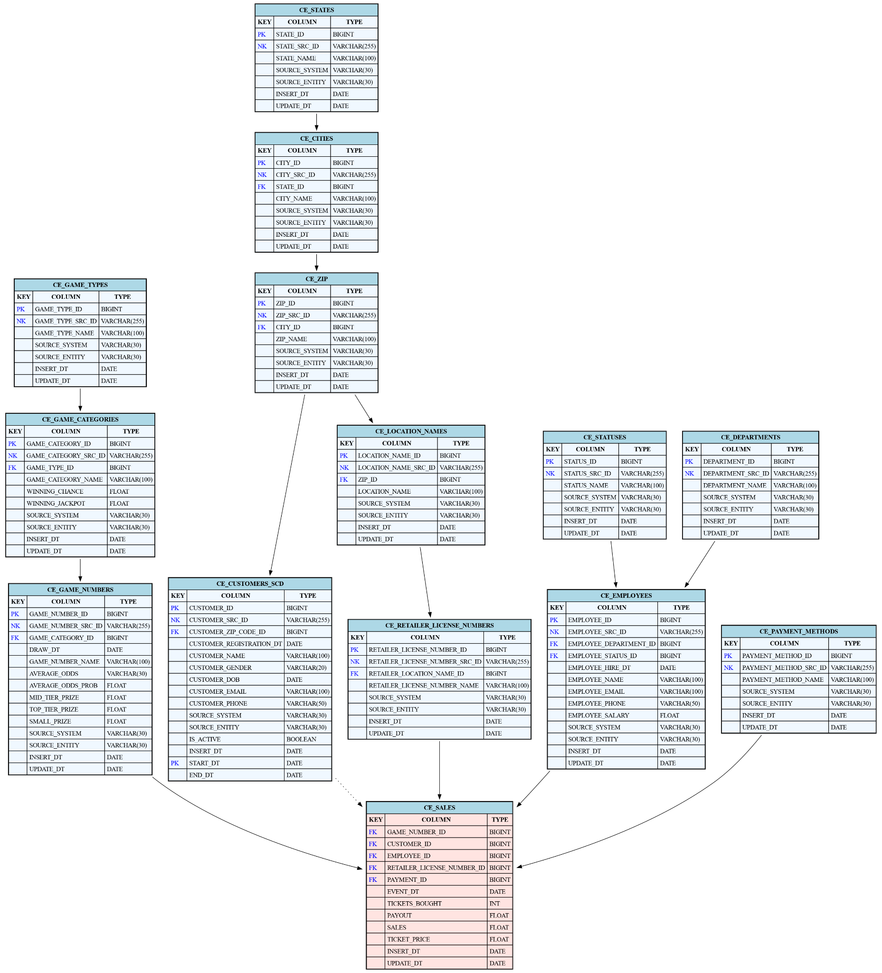

Business Layer Dimensional Model

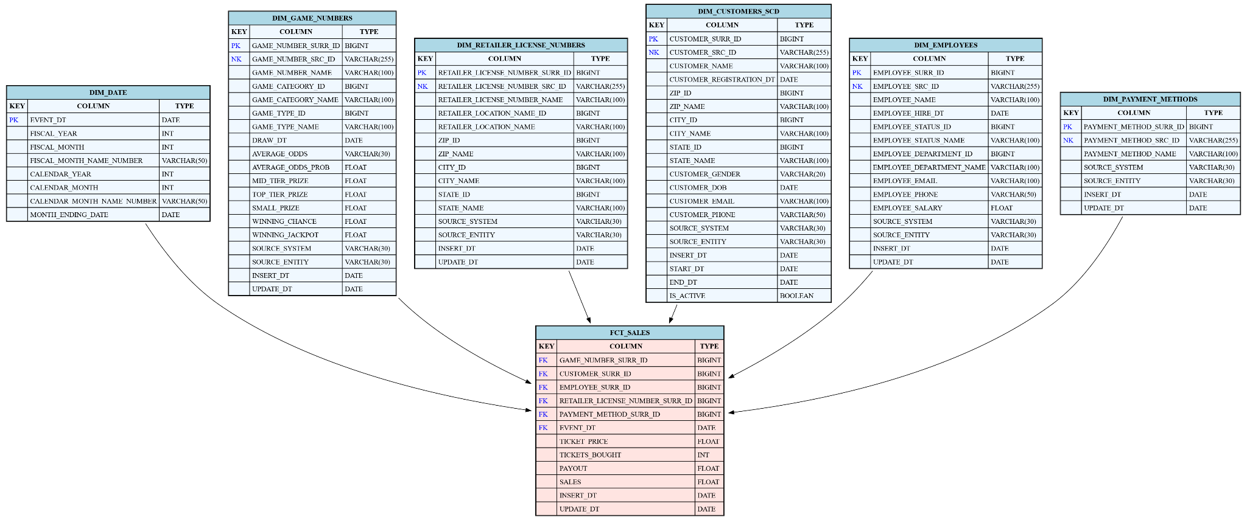

Additional metric

A metric to consider in our fact table is (payout minus sales) divided by tickets_bought. This gives the average net return per ticket, showing how much, on average, each ticket contributes to the player's overall profit or loss.

Logical Scheme
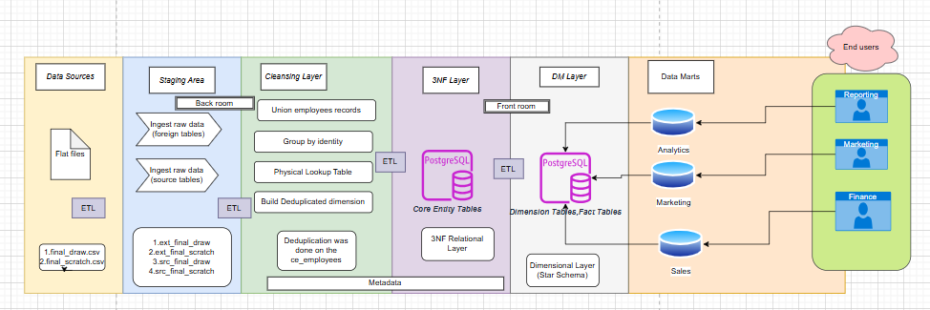

Data Flow

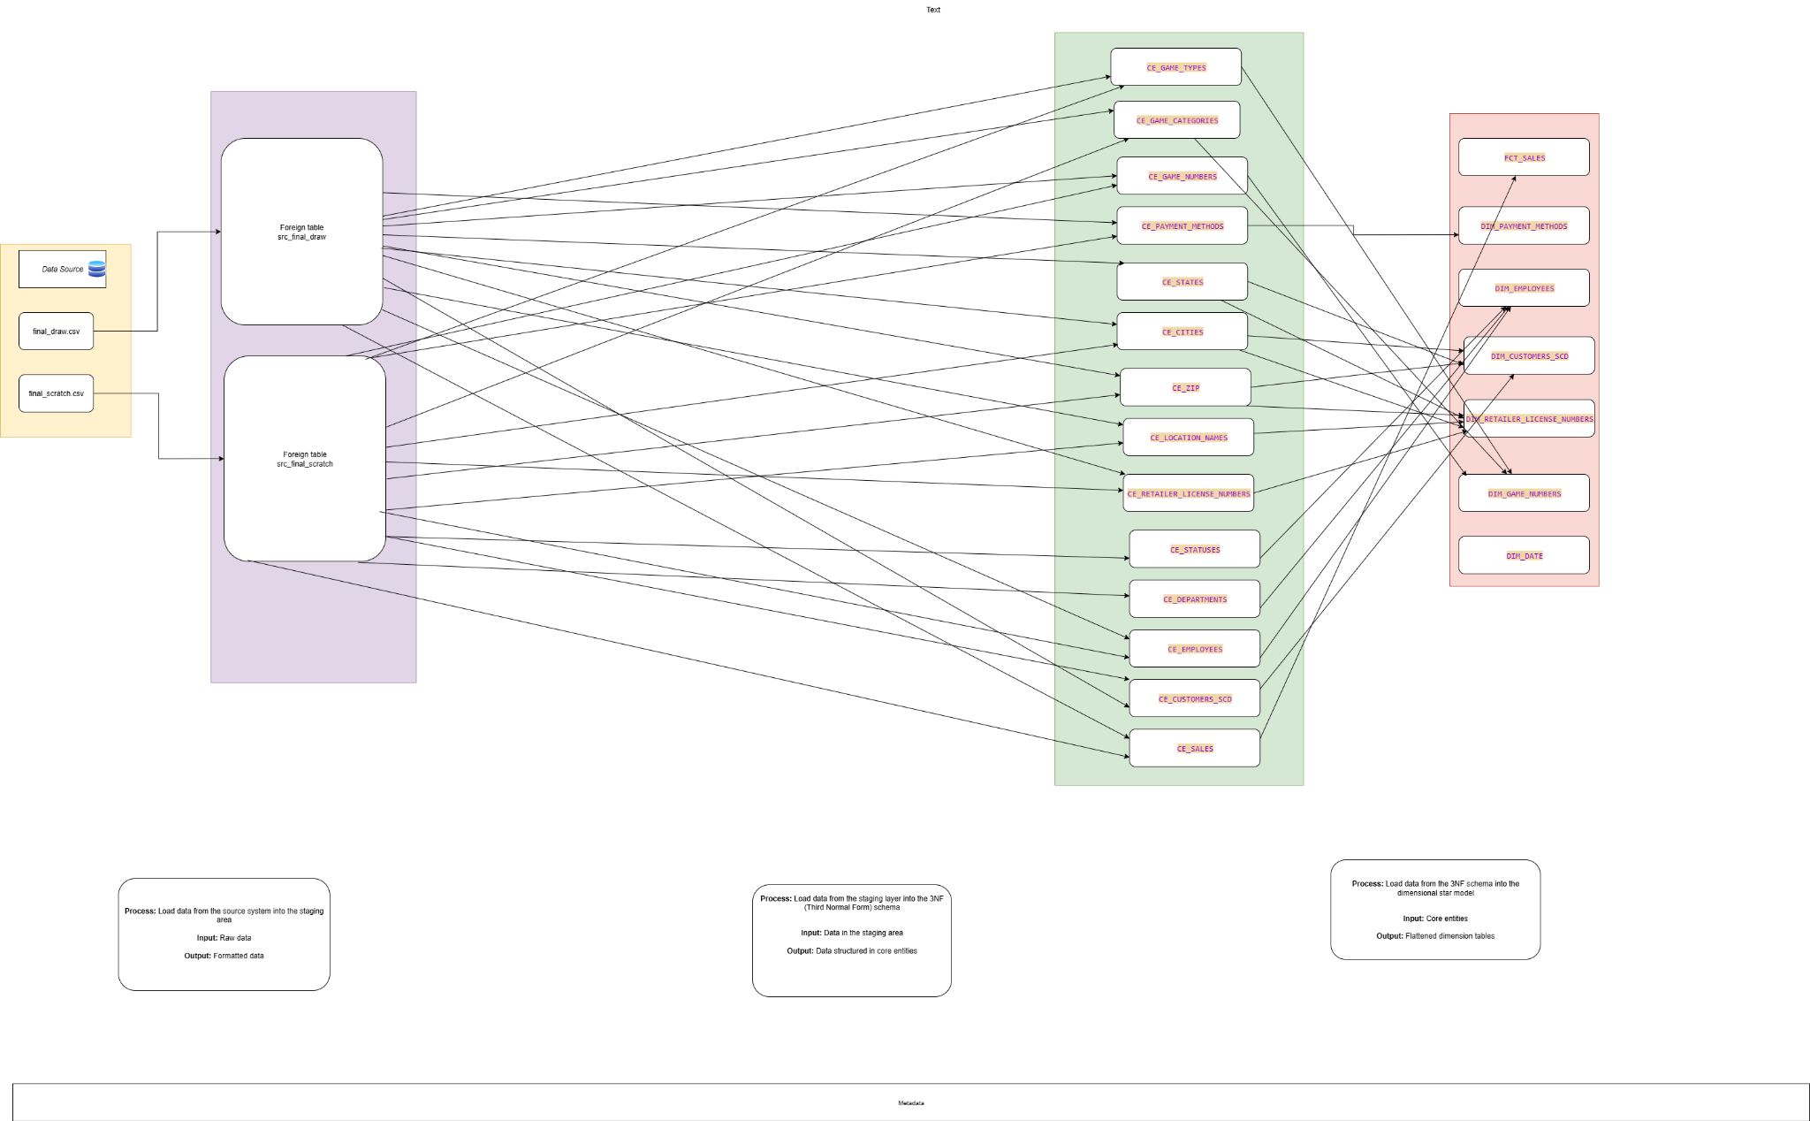

Fact Table Partitioning Strategy
To handle large volumes of sales data efficiently, we’ve implemented a monthly partitioning strategy for the fct_sales fact table, based on the event_dt (event date) column. This allows us to manage and query data more effectively by splitting it into manageable chunks—one for each month.
Instead of loading data daily, we use a 2-month rolling window approach. This means we load two months’ worth of data at a time, and then move the window forward day by day. It ensures that the most recent two months are always available and up-to-date, which aligns well with most business reporting needs.
The process is automated using stored procedures:
- load_fct_sales_rolling_window – loads data into a partitioned version of the sales fact table.
- load_fct_sales_rolling_window_no_partition – loads the same data into a non-partitioned version for comparison.
To avoid duplicate records, we maintain a tracker table that records what data has already been loaded. Before each new load, the process checks this tracker to skip any data that’s already been processed.
We’ve tested the procedures to ensure they’re repeatable and idempotent—running them again with the same input doesn't insert duplicate records. Performance checks showed no major difference between the partitioned and non-partitioned versions in our 3-month test window, though we expect partitioning to become more beneficial as the dataset grows.
Overall, this partitioning strategy helps us:
- Keep recent data always available
- Improve query and load performance (especially as volume increases)
- Simplify maintenance by isolating data monthly
- Ensure clean and accurate data loads with minimal risk of duplication

🏗️ Environment Setup Guide
Pipeline Initialization: From 3NF → Cleansing Layer (CL) → Dimensional Model (DM)
This document outlines the step-by-step process for setting up and running the ETL pipeline. The workflow proceeds through the 3NF, Cleansing Layer (CL), and Dimensional Model (DM) layers. All required procedures, tables, and data must be properly initialized before executing the ETL logic.

📦 Step 1: Create 3NF Layer Structures
In the DDL_BL_3NF script, execute:
CALL bl_cl.create_bl_3nf_all_objects();
✅ Creates all 3NF database objects such as tables, indexes, and sequences.
Then, execute the DML setup for the 3NF layer:
CALL bl_cl.create_bl_3nf_all_dml();
✅ Generates the necessary DML procedures for transforming and loading 3NF data.

🧹 Step 2: Create Cleansing Layer (CL) Structures
Execute the following in the DDL_BL_CL script:
CALL bl_cl.create_bl_cl_all_objects();
✅ Creates tables, indexes, and cleansing logic structures for the CL layer.
Next, run the DML creation for the CL layer:
CALL bl_cl.create_bl_cl_all_dml();

✅ Establishes cleansing and transformation procedures.

🧱 Step 3: Create Dimensional Model (DM) Structures

⚠️ Prerequisite
Before running the DM object creation, execute the full SQL script Task4_Create_Date_hierarchy_date.sql:
-- Run this script in its entirety before proceeding
@Task4_Create_Date_hierarchy_date.sql
📌 This script creates the dim_date hierarchy table and associated structure. It must be executed first to satisfy foreign key dependencies—especially on the sales_fact table.

Proceed with DM Creation
Execute the following in DDL_BL_DM:
CALL bl_cl.create_bl_dm_all_objects();
✅ Creates all dimensional model objects including fact and dimension tables, as well as sequences for the surrogate keys.
Then, run the DM layer DML setup:
CALL bl_cl.create_bl_dm_all_dml();
✅ Generates the ETL procedures for populating and maintaining the DM layer.

📊 Step 4: Load Initial Test Data
In the DDL_DML_sa_src script, execute:
CALL bl_cl.setup_and_load(pct => 0.9);
📥 Loads 90% of data from external staging tables for initial pipeline validation.

🔁 Step 5: Execute Initial ETL Pipeline
Run the complete ETL pipeline:
CALL bl_cl.sp_run_transaction_etl_batch();
🔄 Executes data transformation and movement from 3NF → CL → DM.

✅ Step 6: Validate the Initial Load
Perform the following validations:
- Row counts across 3NF, CL, and DM tables
- Referential integrity and foreign key relationships
- Surrogate key population in dimension tables
- Change tracking and slowly changing dimension logic

📥 Step 7: Load Remaining Test Data
Execute in DDL_DML_sa_src:
CALL bl_cl.load_remaining_from_ext_tables();
📦 Loads the remaining 10% of source data.
🔁 Step 8: Re-run the ETL Pipeline
Execute again:
CALL bl_cl.sp_run_transaction_etl_batch();
🔁 Reprocesses data to capture new inserts and ensure data consistency across all layers.

🔄 Step 9: Simulate Attribute Changes for SCD Validation
From your SQL client, execute:
CALL bl_cl.load_and_insert_all_data();

🧪 Simulates attribute changes (e.g., name, job title) for key entities to validate Slowly Changing Dimension (SCD) logic.

